Guidelines of Full Paper Preparation for ARMS12

First A. Authorª* and Second B. Author^{b}

ª Vietnam Society for Rock Mechanics, Hanoi, Vietnam
^{b}Rock Mechanics Measurement Ltd., Beijing, China
* first.author@gmail.com (corresponding author’s E-mail)

Abstract

This article serves as the template of the full paper (final manuscript) for your abstract submitted to the VCRES2019. The abstract part will be involved in a Abstract Booklet, and the full paper will be published as a proceeding, which will be distributed to all registered participants. Please use this template when preparing your paper. This will ensure a uniform format in the publication. The paper should be written in English and submitted as this MS Word file format and PDF file (in camera-ready form and matching the template for submission). The paper should begin with

- Title: Please provide a descriptive title of the paper. The title should be concise and not span more than 2 lines. Use Times New Roman font with a font size of 14 pts and in bold face for the title.
- Authors and affiliations: Include the first name, middle initial and surname of all the authors. The affiliations of all the authors should be included. The e-mail of the corresponding author should be shown.
- Abstract: Not more than 350 words.
- Keywords: Provide up to 5 keywords, separated by commas. The first letter of each word should be capitalized.
- All the above contents (i.e., title, authors’ names, affiliations, abstract, and keywords) MUST be included within the first page.

The subsequent pages should include numbered sections of Introduction, Theories (or Experiments), Results and Discussion, Conclusions, Acknowledgement, and References. Throughout the paper, use Times New Roman font with single spacing between lines. The recommended font size is 14 pts for the paper title and 11 pts elsewhere. The main text should be justified on both sides. The use of footnotes is discouraged. The paper length should be 6 pages or more but not exceed 10 pages.

Keywords: ARMS12, Rock Mechanics, Hanoi, Slope Stability, Template

- Introduction
- Theories (or Experiments)
2.1 Citation, tables and figures
Sub-titles are allowed in each section. In the text, cite references in the author-year format, e.g. (Author, 1986) or (Author 1 and Author 2, 1997) or (Author 1 et al., 2003) or (Author 1, 2006; Author 2, 2010) or (Author, 2003a; 2003b; 2010). The list of references should be placed at the end of the paper in the alphabetical order. The equations should be justified at the center and the equation numbers in parenthesis should be justified on the right side as Eq. (1).
(1)
The tables and figures should be numbered in sequence and captioned as shown in Table 1 and Fig.1. The followings are the examples for a table and a figure.

Table 1 Porosity, water content and water saturation ratio of Noboribetsu welded tuff.
Porosity (%) | Case | Water content |  | Water saturation ratio (%)
 |  | (mass %) | (vol %)
24.1 | (a) | 0.30 | 0.54 | 2
 | (b) | 6.00 | 10.8 | 45
 | (c) | 12.0 | 21.6 | 90
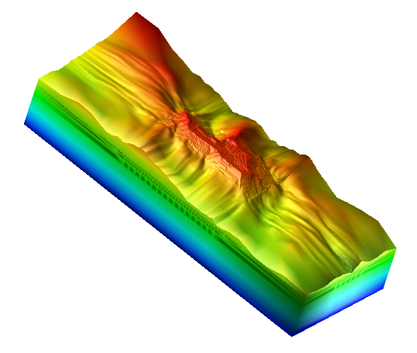
Z
X
11.5 km
4.3 km
2.6 km
Y

Fig. 1. An example of 3-D FEM models for the district including the Torigatayama limestone mine.

- Conclusions
We are looking forward to receiving your paper. For any questions about the guidelines, please contact with ARMS12 registration office at arms12@vietrocknet.org.

Acknowledgements
The Organizing Committee greatly appreciates your contribution to make the symposium fruitful and exciting.

References
Kodama, J., Fujii, Y., Goto, T. and Hagan, P., 2012, Effect of loading rate on strength and failure process of frozen welded tuff, Proc. of 7th Asian Rock Mechanics Sympo., 638-645.
Kodama, J., Miyamoto, T., Kawasaki, S., Fujii, Y., Kaneko, K. and Hagan, P., 2013, Estimation of regional stress state and Young’s modulus by back analysis of mining-induced deformation, Int. J. Mech. Min. Sci., 63, 1-11.

